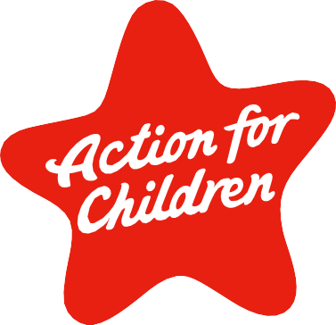

Scotland Trustee
Information Pack
Action for Children Scotland Trustee Info Pack | 1

Contents

Introduction 3
Who We Are 4
Our Finances 6
Meet The Board 7
What We Are Looking For 9
Board Member Specification 10
Time Commitment 11
To Apply 11

Introduction

Dear Candidate
Thank you for your interest in becoming a Board Member of Action for Children.

We have been providing vital support to children, young people and families for over 150 years to people across Great Britain and Northern Ireland.

We are proud of the services we provide that range from accommodation for homeless young people, family support that improves mental health, youth employability programmes, support for young carers, and fostering. You can read more about our national and local services later on in this document.

We are looking for an exceptional individual who is willing to dedicate time and energy to the organisation and share our passion to transform the lives of the people we help. We’re particularly keen to enhance our Board with Human Resources expertise, fundraising skills and governance experience.

You will be joining a dedicated team of people who care deeply about the difference our organisation makes to some of the most vulnerable people locally in Scotland as well as throughout the rest of the UK.

In return you will have the opportunity to be part of an exceptional team of Trustees from every corner of the UK who already bring with them a wide range of skills, experience and networks. Most important to you will be the sense of fulfilment we can offer, of deploying your own your skills and experience to the benefit of the people who need it most.

As a Board, we really value diversity at every level of the organisation, we aspire to improve the diversity of the Board and want to represent all the communities we serve. Appointment will be made solely on merit. However, the Charity is particularly keen to receive applications from female, black, Asian and ethnic minority candidates, and/or candidates with disability who are currently under-represented at this level of the organisation.

We very much look forward to hearing from you.

Yours faithfully

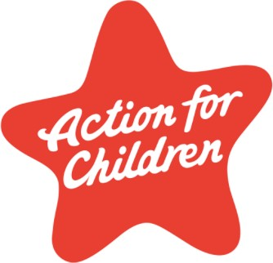
Sarika Patel Chair

Who We Are

Action for Children protects and supports children and young people, providing practical and emotional care and support, ensuring their voices are heard, and campaigning to bring lasting improvements to their lives. We have a track record of delivery that dates back over 150 years and in that time we have grown to be a team of more than 4,500 staff across the UK, supported by £148m of income last year.

Our success lies in stepping in early. We make help available so young people don’t have to reach crisis point. In Scotland we deliver a range of services in communities and reached 20,000 children, young people, and their families last year alone.
Essential to our work with children, young people and families is collaboration within the statutory and non-statutory sectors. Our close partnerships link families and strengthen communities.

Tackling homelessness
Young people can become homeless, or at risk of homelessness, for lots of reasons. Some end up on the streets, others sleep on friends’ sofas and floors. Homelessness among young people is on the rise. We deliver where help is needed.

In West Lothian, our outreach support service helps young adults aged 16-25 find a home and develop key life skills, like budgeting and learning to cook all to help them manage a tenancy

In Moray we have Supported Accommodation Services which provides assistance to vulnerable young people in this key life transition stage, with experienced staff providing a high level of support around the clock.

Support for families
Our family support services are there for families when they need a bit of extra help.

There’s practical support, like helping parents handle bedtimes and homework. We also give emotional
support to families dealing with
challenging behaviour, mental health issues or hardship.

Our Blues mental health programme increases the resilience of young people aged 13-19.
So far, this programme has been offered to all 30 secondary schools in Glasgow. We are extending our reach to Inverclyde, North and South Ayrshire and in South Lanarkshire.

We provide Youth Employability services. Offering both structured training and flexible support to young people aged 16-24 to enable them to progress onto suitable employment, training, or education. These services run in the Highlands, Glasgow, Edinburgh, West Dunbartonshire, North Lanarkshire, South Lanarkshire, Inverclyde, East Ayrshire, North Ayrshire, and East Lothian.

We also support young carers. Many children and young people in Scotland look after a family member. We give them opportunities for break, as well as emotional support.

Fostering
Young people who enter foster care have often had difficult childhoods. They may have experienced upsetting or unsafe situations. Some will carry the effects, including challenging behaviour and emotional trauma.

Our fostering service finds them safe and loving homes. We train and support carers to give children and young people the attention they need to thrive.
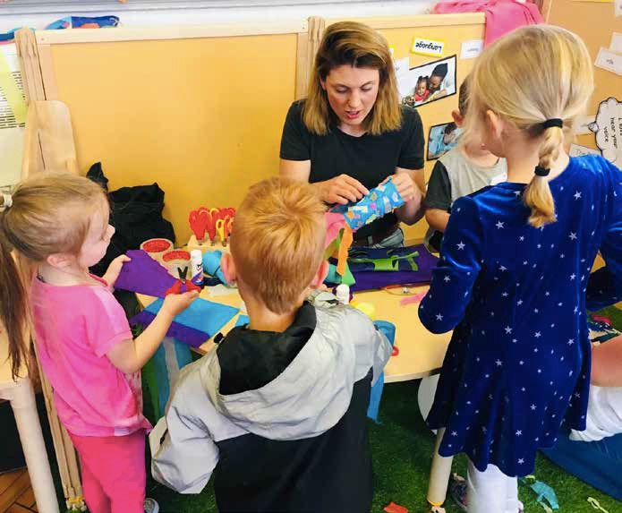

Our Finances
We’re proud of the sustainability and strength we’ve built up as an organisation. It equips us to serve the children, young people and families who need our help the most. Last year our income was £148m more than 95% of which was unrestricted. Our balance sheet was worth £75m. Our income supported more than 4,500 staff and the work of thousands more volunteers. You can click on the links below to go straight to our three most recent annual reports.

Action for Children Annual Report and Accounts 2019/20

Action for Children Annual Report and Accounts 2018/19
Action for Children Annual Report and Accounts 2017/18

Meet The Board
We have a UK-wide Board with four National Advisory Committees.

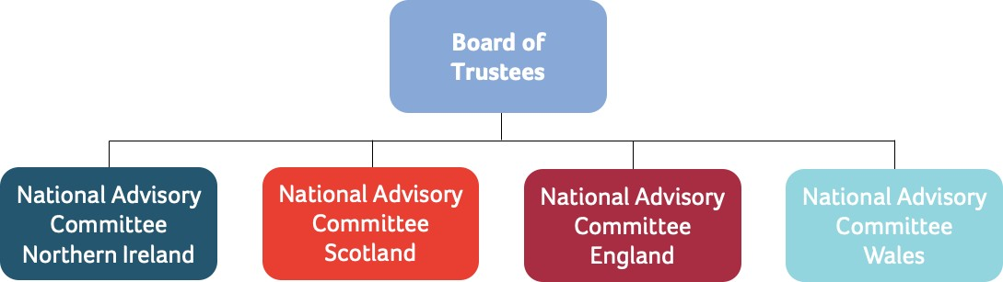

Here are our current UK-wide board members. You can find more details about them on our website too.

Sarika Patel

Sarika is Chair of the Board of Trustees and a business leader

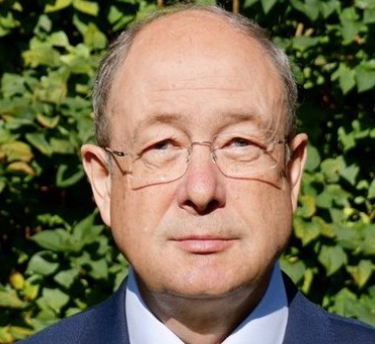
Markus Ruetimann

Markus has a background in financial services in Zurich, Geneva, New York and London

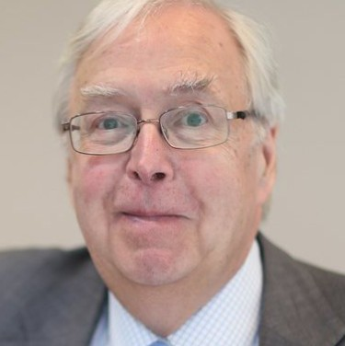
Richard Cryer

Richard is a former Director of Finance for higher education and financial services

Enda Johnson

Enda has a background in financial services, including corporate affairs, finance and strategy

Dawn Warwick

Dawn is a social care specialist with 17 years of director-level experience

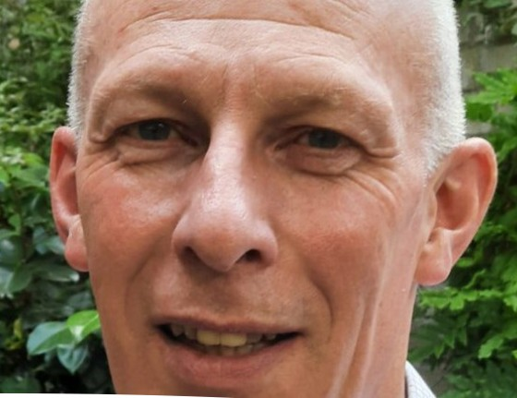
Michael Long

Reverend Long is Minister of Notting Hill Methodist Church

Gary Edwards

Gary has more than 38 years’ experience in business transformation, engineering and IT

Steve Bell

Steve was a Partner at EY from 1999 until retiring in 2020

Peter Curran

Peter is currently the Chief Finance Officer for the South Wales Police and Crime Commissioner

What We Are Looking For
We’re hoping to enhance the current Board’s collective portfolio of skills and experience, particularly in the areas of:

Human Resources

Fundraising

Governance
This is not an exhaustive list and if there are other skills and qualities that you feel relevant that would add value to Action for Children Board, we invite you to submit your CV. Action for Children is very committed to diversity and equality of opportunity and welcomes applications from all sections of the community.

Role purpose: To contribute to the leadership and governance of Action for Children

Key accountabilities Key elements and tasks

To contribute to the leadership of Action for Children

Contribute to effective decision making by the trustee Board.

Fulfil the legal requirements of being a trustee.

Understand and promote the goals of Action for Children in Scotland
- Contribute to the development and monitoring of Action for Children’s Strategic and Business Plans;
- Uphold the aims, principles and values of Action for Children;
- Represent Action for Children at local and regional events;
- Communicate, explain and support the decisions of the trustee Board.
- Prepare for, attend and contribute to six trustee Board meetings each year;
- Prepare for, attend and contribute to the Annual General Meeting;
- Prepare for, attend and participate in trustee strategic/planning days;
- Participate in trustee Board committees and working groups;
- Represent Action for Children at occasional meetings and events;
- Apply independent judgement to all issues under discussion at Board meetings.
Ensure Action for Children:
- Fulfils its charitable purposes;
- Remains financially viable;
- Complies with all legal requirements;
- Fulfils its responsibilities as an employer;
- Understands the importance of good practice in human resources management and staff development;
- Is committed to ensuring equality of opportunity in service provision and employment;
- Has a process for appointing and monitoring the performance of the Chief Executive.
- To generate income and control expenditure so that the annual surplus targets are is reached;
- To chair the National Advisory Committee for Scotland over time;
- Be an ambassador for the charity, promoting its interests and taking care to present it in a positive light;
- To cultivate links to Scottish stakeholders who can help Action for Children deliver on its mission.

Board Member Specification
Those interested in serving as an Action for Children trustee must be able to demonstrate that they:

  - Have leadership skills, including the ability to be objective, to probe and question, and to act decisively when necessary.

  - Are visionary, creative and passionate about Action for Children’s mission and prepared to invest energy in its success by learning and understanding its business and its stakeholders.

  - Are team players, able to listen and work with others, offering guidance and support, to ensure effective decision-making by the Board.

  - Understand the responsibilities of company directors and company trustees, the importance of good governance, and agree to work in accordance with any code of practice agreed by the Board. Ongoing support, learning and development opportunities will be offered to trustees with this.

  - Are good communicators, willing and able to promote the decisions of the Board and the interests of Action for Children and the people it helps.

  - Are able and willing to act impartially and apolitically.

  - Have strong analytical skills, can assimilate information and grasp complex issues quickly, and then apply independent judgment.

  - Can demonstrate actively promoting Equality, Diversity and Inclusion.

Candidates must disclose any information about their personal or professional life which in the trustee Board’s perception could bring Action for Children into disrepute, including removals from previous governance roles, current or previous membership of organisations which may conflict with the aims, principles and values of the organisation, or behaviour which might be seen to undermine public confidence and trust.

Candidates must also disclose if they have been convicted of a crime, which debars them from acting as a company director, or they are an undischarged bankrupt or disqualified to act as a company director.

Candidates must disclose any information, which could give rise to a perception of conflict of interest with their role as an Action for Children Board member. This will not necessarily result in an inability to serve on the Board.
Action for Children Scotland Trustee Info Pack

Time Commitment
Overall Estimate: Twelve to fifteen days a year, with need for flexibility to attend evening events if needed.

(Less during COVID-19 due to online meetings)

Term of Appointment: Initial three-year term, renewable by agreement to a
maximum renewal of two terms, for both the UK Board and National Advisory Committee for Scotland

UK Board Meetings: Every two months, usually a Wednesday. Duration is
around 4 hours, including 30 minutes for a Trustee pre-meeting.

National Advisory Committee
Scotland Meetings: Four a year, March, July, September and December,
subject to change.

Expenses There is no remuneration for this role but out of pocket expenses are available in-line with Action for Children's financial policy and procedures.

To Apply
Please submit a CV and a supporting statement, addressing why you are suitable for the role, by email to AfCGovernance@actionforchildren.org.uk

Do let us know if you have any access requirement to participate in any stage of this process.

Your application will then be considered by the Board who might invite you to an interview with the Chair and other Trustees to discuss how you meet the criteria set out in the role, and the level of commitment you can make to this voluntary role.

Feel free to contact Georgia Toutziari on 07813 400435 if you would like a confidential conversation about the role, or if you have any questions.

Action for Children Scotland Trustee Info Pack

For queries about the recruitment of the ScotlandTrustee, contact
Georgia Toutziari
Action for Children
Call 07813 400435
Email georgia.toutziari@actionforchildren.org.uk
Action for Children

19 Great Queen Street
London
WC2B 5DG
actionforchildren.org.uk Action for Children
Registered charity nos. 1097940/SCO38092
Company no. 4764232

