For further information, please contact:

VALERIE RUSSELL
Children’s Services Manager
valerie.russell@actionforchildren.org.uk
Tel: 01851 705080

For Lewis & Harris:

GRACE MOONEY
Wellbeing Practitioner
grace.mooney@actionforchildren.org.uk
07977 159630

For Uist & Barra:

Wellbeing Practitioner

07977 159632

Website: www.actionforchildren.org.uk
Facebook: Action for Children – Outer Hebrides

Action for Children, whose registered address is at 3 The Boulevard, Ascot Road, Watford WD18 8AG and registered as a charitable company limited by guarantee in England & Wales under number 4764232. Registered charity numbers 1097940/SCO38092.

Confidentiality

Service User’s information is treated as confidential within the project and will only be shared with the knowledge and permission of the service user except when a child or vulnerable person is at risk.

Equality & Diversity

We respect differences in ethnic origin, gender, religion, sexuality, culture and language both as an employer and service provider.

We will endeavour to communicate in people’s first language and will ensure participation of those with disabilities.

Participation

Young people and their families will be included in meetings and reviews about the progress they are making, and their views will be sought before any decisions are made.

They will be asked for their views about the service they are receiving.

They will be encouraged to aid in the shaping and developing of the service.

Comments / Complaints

If you have any problems or concerns about the service, please speak to a member of staff. Any problems or concerns will be dealt with promptly.
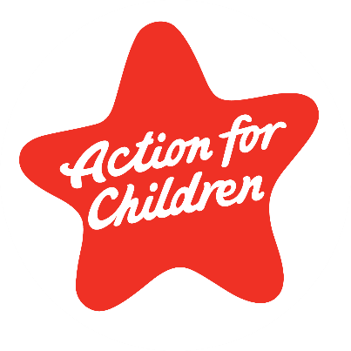
Eilean Siar
Wellbeing Service

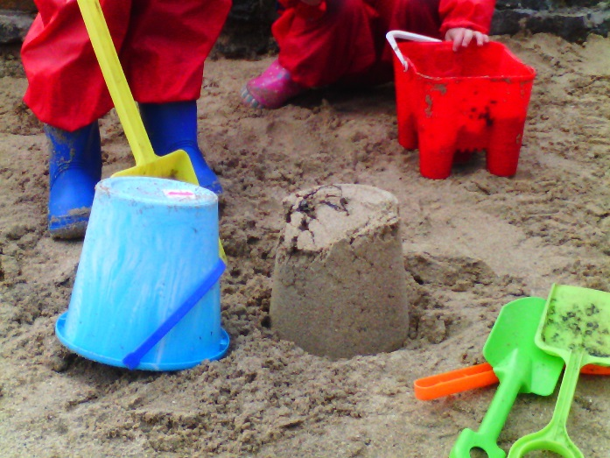

Who We Are…

Action for Children work in partnership with secondary schools across the Outer Hebrides; Sgiol Lionacleit, Sir E Scott, the Nicolson Institute and Castlebay Community School, to provide early intervention and prevention support to pupils experiencing mild mental health and wellbeing related issues.
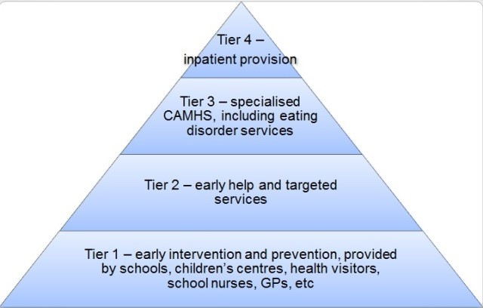

Who We Help…

Our early intervention service works across Lewis, Harris, Uist and Barra with young people throughout their time in Secondary School. The Wellbeing Service aims to reach pupils needing Tier 1 and part of Tier 2 support.
What We Do…

- We provide support to improve mental health and emotional wellbeing of young people through 1-2-1 and group support.
- We will provide support that is led by the needs of the young people we are working with.
- Support in 1-2-1 session will be working towards a specific goal, these can relate to: Self-confidence, dealing with conflict with friends, dealing with change, identifying emotions, Self-care, understanding boundaries, of selves and others, developing an emotional toolbox, being able to make decisions and building emotional resilience.
- We will also be providing and implementing evidence based, early intervention programs, such as, The Blues Program, Bouncing Back and Cognitive Decider Skills.
- Group session may also take place to support young people with relevant issues that they face. This will be determined by conducting regular reviews, talking to young people and understanding common themes.
Referrals…

Referrals can be made through self-referral by the young person, or by school staff. The young people can stop using the service at any time. Those referring should have a timeline in mind. This referral criteria are subject to change as the young people’s need change over time. This referral criteria aims to ensure young people are receiving the right support from the right services. The Wellbeing Services aims to address tier 1 and parts of tier 2 of the tiered services triangles. If you have any questions regarding the referral criteria, please get in touch with the Wellbeing Practitioner.

Comments…

If you would like more information or have any suggestions, please contact Grace Mooney. Grace is primarily based in Sir E Scott on Monday and the Nicolson Institute Tuesday to Friday, you are welcome to see her in any of the drop-in sessions.

